**Ex3 Classes Description and Diagram**

**By Lior Roife (206257826) and Maor Zemach (206273690)**

**Classes:**

1. Public ValueOutOfRangeException - Inherits from the Exception class, throws exception whenever the an input isn't in required range.
2. Public Program - The main class where the first 'Garage' object instance is created in and where the garage system ran from.
3. Public Static UIInputsOutputs - responsible for printing to the console and receiving data from the user.
4. Public UIManager - the user interface, where the interaction with the user takes part.
5. Public Garage - A class that contains information and methods related to the garage, it has a dictionary structure of 'Vehicle' (objects) and 'Vehicle License Numbers' (strings) and basically holds the main data of the garage system.
6. Public abstract EnergySource - An abstract class of energy source that is a data member of any Vehicle object.  
   This class contains characteristics and methods for energy and electricity sources.
7. Public FuelSource: EnergySource - Inherits from the class EnergySource. Contains properties and methods that can be applied to a fuel-type energy source.
8. Public ElectricSource: EnergySource - Inherits from the class EnergySource. Contains properties and methods that can be applied to an electric-type energy source.
9. Public abstract Vehicle – An abstract class that can be applied to all types of vehicles (Motorcycle, Car, Trucks and other vehicles that might be added in the future).
10. Internal Motorcycle: Vehicle - Inherits from the class Vehicle.  
    Contains features and methods that can be applied to a motorcycle-type vehicle objects.
11. Internal Car: Vehicle - Inherits from the class Vehicle.  
    Contains properties and methods that can be applied to a car-type vehicle objects.
12. Internal Truck: Vehicle - Inherits from the class Vehicle.  
    Contains characteristics and methods that can be applied to a truck-type vehicle objects.
13. Public Wheel - A class contains properties and methods of a wheel type objects.

**Enums:**

1. Public eMenuOption - The possible action options in the garage system menu.
2. Public eCarColor - The possible 'Car' (object) colors.
3. Public eAmountOfDoors - The possible amount of doors in 'Car', 'Truck' (objects).
4. Public eLicenseType - The possible 'Motorcycle' (object) license types.
5. Public eFuelType - The possible fuel types, 'Soler', 'Octan95', 'Octan96', 'Octan98'.
6. Public eVehicleType - The possible Vehicle (object) types, 'Motorcycle', 'Car' and 'Truck'.
7. Public eEnergySourceType - The possible energy source (objects) types, 'Fuel', 'Electric'.
8. Public eVehicleStatusInGaragae - The possible vehicle statuses in the garage, 'InRepair, 'Repaired','Paid'.

**Classes Diagram**

Ex03.ConsoleUI:

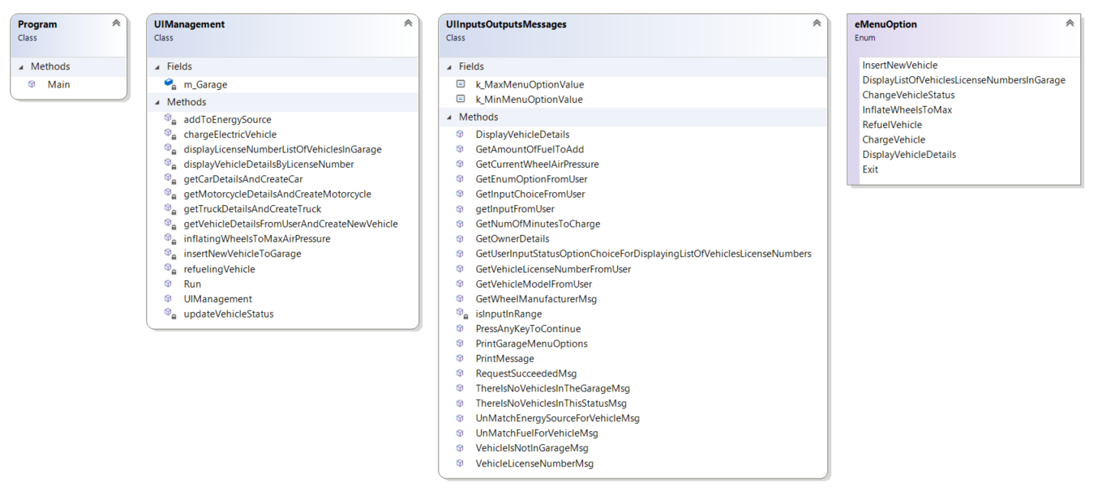

Ex03.GarageLogic:

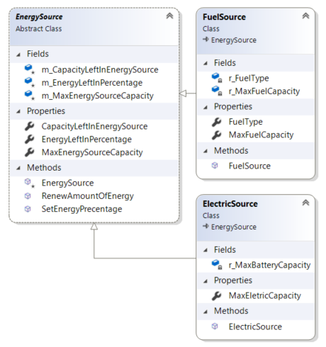 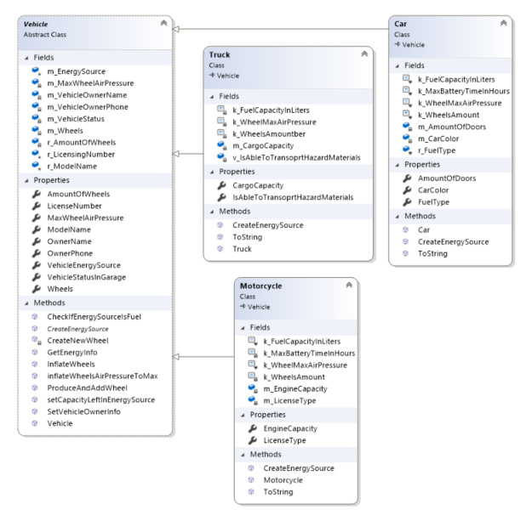

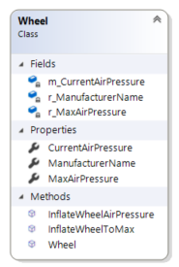

eNums:

